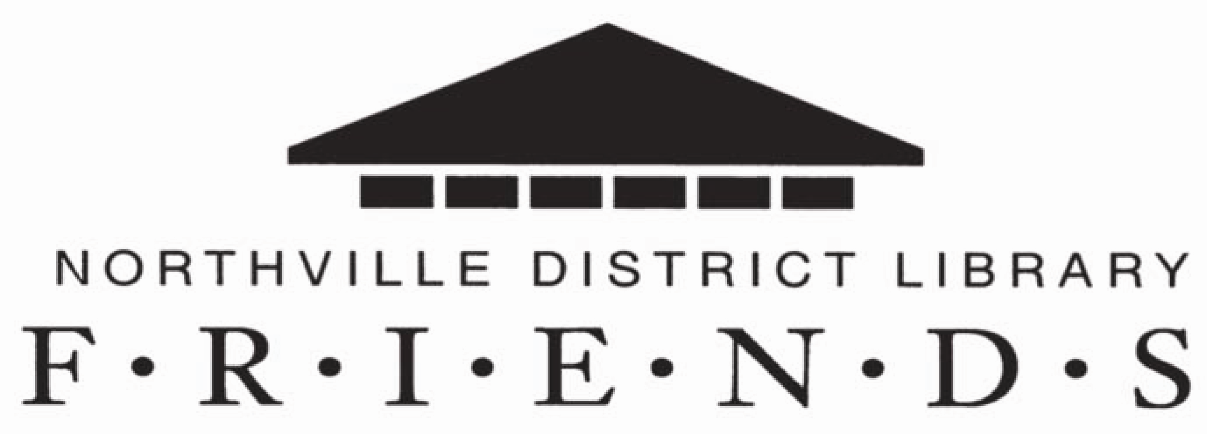

Board of Directors Meeting
Thursday, April 21, 2016

Minutes

Members Present:
Martha Nork, Scott Frush, Deborah Stanifer, Linda Bolam, Carol Oldenburg, Sandy Walts, JudyDeFrancesco, Claire Kreher, Chris Litka, Regina Mingela, Linda Schwelnus, Jim Morche, Betty Kaiser, JoAnn Kissel, Doug Witt, and Julie Herrin, Library Director

Guest: Suzanne Schimanski-Gross

- Call to Order
Meeting called to order at 7:00 P.M. by President, Martha Nork.
A group picture of the newly elected Board of Directors was taken.

- Approval of Agenda
The agenda was APPROVED.

- Approval of Meeting Minutes of March 17, 2016
The minutes were APPROVED with two corrections:
Section VII, B Gift Store – add “new lighting” to item #2.
Section VII, D Read to Me, item #2 – Books needed by March, not September.

- Library Director’s Report – Julie Herrin
  - Statistics
    - Circulation is up by 6.63%
    - Door count was up by 2.5%
    - Computer use and wi-fi were up
  - Programs
    - Very successful with nearly 80 signed up for special programs.
      - Large number of “no-shows” however. We will try using appointment cards to act as reminders when they sign up at the library desk for programs.
      - Test program will be held at the Northville Township Hall in December.
      - An ESL Conversation Group is being held weekly at The Next Chapter. The average attendance has been eight.
  - Planning
    - The Library Board has decided to contract with Bolan and Associates for a Space Study.
    - There will be a project team and Martha will be on the team as a Friend’s representative.
  - Public Relations
    - The Anniversary Party will be Sunday, October 16th. Chris Litka volunteered to be the Friends representative on the planning committee. Meetings will be started shortly.
    - The Friends presence will be a good way to foster Friends membership and show the community it’s Library and the Friends.
    - Business showcase
      - There were fewer booths and fewer attendees this year.
    - Summer Sidewalk Event
      - Library participation will be outside in front of the library. The Business Merchants Association sponsors this event. The date has not been decided yet.

- Library Staff Special Report – 10th Annual Battle of the Books – Suzanne Schimanski-Gross
  - This event draws participants from middle school students from all Northville Public Schools, Our Lady of Victory School, and home-schooled students.
  - The students read seven selected books on a variety of topics and then answer trivia questions based on the books.
  - Twenty-five teams participated, with an average of 2-6 members per team. The teams have names and often dress in costumes. 1618 students have participated over the past ten years.
  - National Honor Society Students volunteer with the program.
  - Prizes are awarded to the top three or four teams.

- President’s Report – Martha Nork
  - Karen Fehl has been receiving questions about our Spring Used Book Sale. She suggested that we put a notice on the UBS page on the Library website that the Friends are not having the book sale this spring.
  - The Library trustees have asked for a Friends member to be on their Grant Subcommittee. They are researching grants for low vision equipment. Linda Schwelnus has volunteered to participate with this.
  - Signs from the March library display case have been moved to the Friends’ portal at the entrance to the Children’s area. New gift book donations are shelved there along with the Gjft Book records. The library also purchased a Lucite holder to display volunteer forms for the Friends in this location.
  - I attended a Rise & Shine Networking meeting of the Northville Chamber of Commerce at the library on Feb. 3, and will attend the Networking meeting on April 27th at the Northville Art House.

- Treasurer’s Report – Deborah Stanifer
  - Our March account balances show a beginning balance of $69,865.67. The ending balance as of 3/31/16 is $78,218.61.
  - Income is doing well, especially related to Membership Dues and Used Book Sales.
  - “Donations” will be broken down in the future as: General donations, and Specific donations.
  - The report was APPROVED.
  - Please notify Deborah if you have any need for postage stamps.

- Committee Reports
  - Membership – Regina Mingela
    - Our current membership is 156.
    - The library currently hands out approximately 100 Welcome Packets every month, including Friends’ membership applications. Thus far, no one has joined the Friends through this effort.
    - Regina questioned if she should continue to make 100 copies per month and fold them, or should we ask Max Printing to do this task, or should we concentrate our efforts on face-to-face contact, as Judy DeFrancesco does with Read-to-Me, Jim Morche does at guest events, and some of the store volunteers do with customers?
    - Ideas presented included: (1) Discontinue inserts from the library Welcome Packet, possibly including a Friends’ bookmark instead; (2) Distribute membership forms to all local residents; (3) Have Friends’ representative at all programs; (4) Send out the Friends’ membership form to our own friends who may not be members of FNDL; and (5) Distribute membership forms to the Northville Newcomers and Neighbors.
  - Gift Store – Linda Schwelnus
    - Sales for March were $1382: profit for March was $1163, but bills are coming in.
    - Reminder that Member Shopping Days are April 28 to May 1. Friends receive a 25% discount on purchases during this time.
  - Gift Books – Claire Kreher
    - Since 3/17/16 we have received 2 Gifts, 1 Memorial, 1 Honor, for a total donation of $75.
    - We have been able to add eight books to the library collection.
  - Newsletter – Sandy Walts
    - The next newsletter will be out in July. Tentative deadline is the end of June.

  - Read to Me – Judy DeFrancesco
    - The program is doing well as the year comes to an end. Eighteen bags were given away at the last meeting.
    - Our supply of Sesame Street Growth Charts for the gift bags is running out. Possible replacement idea is a beach ball with: “Read- Northville District Library”, @ $1.27/Ball.
  - Programs – Jim Morche
    - Six more programs are scheduled this year:
      - Hubble Telescope – May 10th, with Jesse Lee Mason. Sixty participants have already signed up. Chris Litka will send out publicity email.
      - Picks & Sticks – with three performers, will be scheduled in July or November.
      - Veteran’s Program – the first week of November
      - Twelfth Night – December
      - Pirates of the Great Lakes – October
      - Bluegrass Program – date to be determined.
  - Public Relations – Chris Litka
    - A Facebook icon will now be added for Gift Store emails – FNDL Gift Store, with the assistance of Michael.
    - We now have a generic email address, Friends PR Coordinator, instead of a personal email address. Thanks to the generosity of the library that is paying for our address on their system, we were able to accommodate the requirements of Mail Chimp with no disruption.
  - Used Book Sales – Carol Oldenburg
    - Vendor sales are up 15% this month.
    - Cart sales are up 51%
    - Total month’s income is $2,316.69.
    - The reasons for discontinuing the Spring and Fall Used Book Sales were reviewed. Reasons included the decrease in available manpower and volunteers, storage space for the books, availability of rooms at the library, and the cost of tables and book transport. A motion was made and PASSED to discontinue the Fall Used Book Sale.
    - We need to remind people to continue book donations and increase advertising the new Book Cellar hours and our improved supply of current books in good condition.

- Old Business
  - Sundaes on Sunday
    - The date for this event has been postponed for this October because of Friends’ participation in the Library Anniversary Party on October 18th.

The meeting adjourned at 8:22 P.M.

The next meeting is scheduled for May 19, 2016

Respectfully submitted,

Linda Bolam, Secretary

